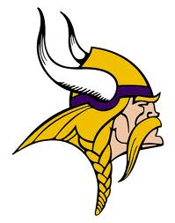
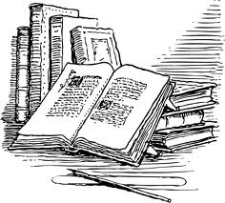
WESTHILL HIGH SCHOOL
SUMMER READING 2014

These projects were designed for you to demonstrate that you have gained a thorough understanding of the novel without writing a standard book report or taking a test.
- Choose your own Novel!
- Choose your own Projects!
- Choose your own Grade!
- CHOOSE your own ADVENTURE!
You may choose any full length work (fiction or non-fiction) that is age and grade level appropriate. If you would like some book suggestions NPR has published a list of the top 100 Young Adult novels on their website (http://www.npr.org/2012/08/07/157795366/your-favorites-100-best-ever-teen-novels). You might also want to consider a work by canonical authors such as:

- Jane Austen
- James Baldwin
- Charles Dickens
- William Faulkner
- Thomas Hardy
- Henry James
- Cormac McCarthy
- Toni Morrison
- Joyce Carol Oates
- Alice Walker

Once you have chosen your book take a look through the following project options. Your assignment is to complete a combination of the following projects that will total 100 points. The point values are listed. If you choose to, you can even do the same type of project more than once, to bring your total point value to 100. Or have some fun – try out different projects/ways of expressing what you’ve learned!

Remember: this project represents your FIRST grade in English in the 2014-2015 school year. Make it count! You will be expected to share your project with your ELA class, so take pride in what you do! And as always, plagiarism will NOT be tolerated – be original, be creative, be you.

ALL STUDENTS ARE EXPECTED TO BRING THEIR COMPLETED PROJECTS TO SCHOOL ON FRIDAY, SEPETMBER 5, 2014. They will be graded by your English Language Arts teacher. Please note: 100 points is the STARTING grade, but not a guarantee – lack of effort or failure to follow directions can bring it down from there!

Please note that students taking AP Language (11) or AP Literature (12) are not required to complete this school-wide summer reading assignment. AP students have a DIFFERENT assignment, which was handed out in June and is also available on the Westhill website.

If you have any Summer Reading questions, please email Ms. Wheeler or Ms Tobin: cwheeler@StamfordCT.gov or ktobin@StamfordCT.gov.
100 Point Assignments—these demonstrate a thorough knowledge of the entire novel. (Do ONE of these, and you’re DONE!)

*For each project in this category, you must incorporate 5 major quotations from the novel (you pick ’em!) making sure to use and explain them in a way that fits your project.

1) Whole Novel Collage → Create a word and/or picture collage representing the entire novel (main characters, major events, turning points, etc.). This must be done on a large sheet of drawing paper or poster board 20”x32” minimum (8.5”x11” printer paper is too small). This must be accompanied by a one page written explanation of why you selected the certain words and/or pictures, AND why you placed them as you did on your poster. The overall project must be neat and aesthetically pleasing. (Hint: consider including your five quotations as part of the collage, or in the explanation for items in the collage!)

Romeo & Juliet collage - samples

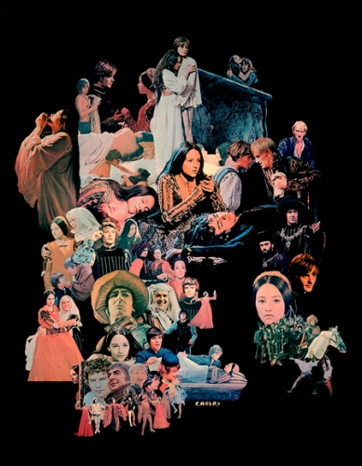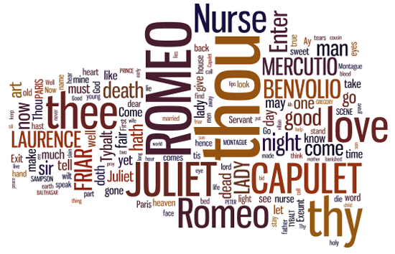

A picture collage – explanation of what pics are used and why they are used would be on the back of the collage. EXPLANATION IS JUST AS IMPORTANT AS COLLAGE! | A world-cloud collage (Wordle.com) – explanation of what the layout of words, colors, sizes, etc. would be on the back of the collage. EXPLANATION IS JUST AS IMPORTANT AS COLLAGE!

2) Newspaper / Blog → Create a newspaper or blog about the entire novel that includes such things as classified ads, obituaries, news items, sports articles, cartoons, etc. Consider: what sorts of columns or articles would this novel “inspire”? What might various characters write, be in charge of or contribute? (sections, pictures, etc.) Can be produced in MSWord or other program and printed on regular printer paper, or done on a site like Blogger, but remember: the more pages you include in your newspaper or blog, the close to an “A” grade you’ll be! (Hint: consider including your five quotations as part of the articles, columns, captions, and so on!)
3) Board game → Create a board game in which the game pieces represent the characters and the board shows the plot sequence / main events of the entire novel. Your game must include rules (inspired by the events of the novel, like the “rules” of the characters world) and be “playable”. For inspiration, take a look at games like Life, Monopoly, Clue, or Taboo. (Hint: consider including your five quotations as directions on the game cards, in the rules themselves, in creative ways on the gameboard, or however you can!)

Lord of the Rings boardgame - samples

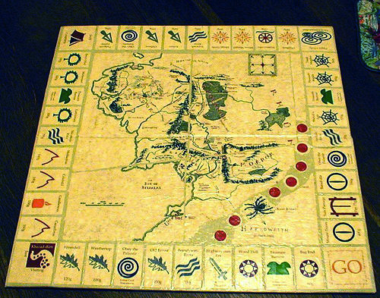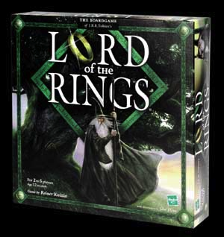

4) Comic Book → Re-write the novel in comic book form. You should remain true to any physical or setting descriptions. HOWEVER, you will probably have to cut out some dialogue, and possibly even some scenes. You should include a one-page write up with your comic book, explaining what you KEPT in, what you LEFT out, and why. Also, how you chose to visually depict scenes and characters – what they looked like in your imagining and why… (Hint: consider including your five quotations as part of the comic book, or in the explanation!)

Hamlet comic - samples

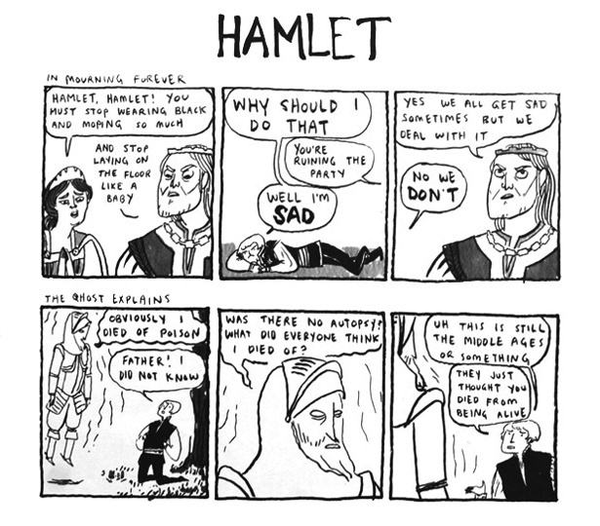

50 Point Assignments—while still thorough, these projects do not necessarily showcase the novel in its entirety. (Do TWO of these, and you’re DONE! Or, do ONE of these, and TWO from the 25 point category!)

*For each project in this category, you must incorporate 3 major quotations from the novel (you pick ’em!) making sure to use and explain them in a way that fits your project.

1) Alphabet → For each letter of the alphabet, write a word (noun, verb, adverb, or adjective) that is relevant to the book. You CAN’T “repeat” yourself by using words that are too similar! Think in terms of descriptions of characters (personality, actions, “looks”), major events in the novel, themes, and so on! Write at least 1 sentence, for each word, that tells why the word is significant to the novel. Make sure to mount all your words on a poster, do something creative with them in terms of font / typing, or otherwise put in effort. (Hint: consider working your 3 quotations into / onto the poster, for visual interest!)

2) Original Art → Create two pieces of art about the novel – each should be a minimum of 8.5”x11”. They can be portraits of characters, significant events, movie posters!, anything, and in whatever medium you choose – draw, paint, photograph, computer art, etc. These should be accompanied by written pieces explaining them. For both pieces, include a write-up on the back explaining the choices you made as artist to tie the work to the book – colors, dimensions, sizes, placement. (Hint: consider including your three quotations as part of the explanations!)

Moby Dick movie poster - Sample
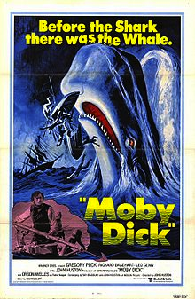

3) Songs / Poems → Select (from outside sources – famous poets / poems, famous song lyrics) or WRITE 10 poems / songs that you feel say something about the theme, mood, characters or settings of the novel. Compile these into a book / binder, and include for each an explanation of why you selected or wrote each poem/song. IF YOU WRITE ALL TEN yourself, you may count this as a 100 point project, not a 50 point project. (Hint: consider including your three quotations as part of explanations, OR even work them into the lyrics / words of your work!)

4) Fan Fiction → Write a new ending for the story, a new adventure for the main character, or the beginning of a sequel. The tone and format should be the same as the original novel. If you get rid of old characters, tell what happened to them; if you invent new characters, describe them. Your novel “rewrite” should be at least two full pages (500-750 words) and your explanation of the choices you made in writing it should be at least one full page. (Hint: consider including your three quotations as part of the rewrite, OR even work them into the explanation!)

25 Point Assignments—these demonstrate a thorough knowledge of certain events or characters from the novel.

*For each project in this category, you must incorporate 1 major quotation from the novel (you pick ’em!) making sure to use and explain them in a way that fits your project.

1) Paper Dolls → Make paper dolls of the main character(s). Research the types of clothing worn during the era (if the story is set in a different time period) or check for clothing descriptions in the book and make a wardrobe for them. The dolls and their garments should be true to the physical descriptions given in the book. Either have one doll, and at least three outfits for the doll, or three dolls with one outfit apiece. Have a standard size notecard for each outfit, explaining why you depicted it as you did. (Hint: consider including your 1 quotation as part your explanation!)

A Midsummer Night’s Dream paper dolls - Sample

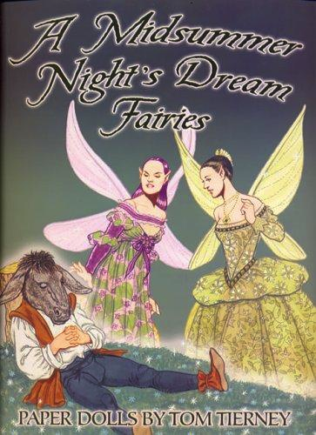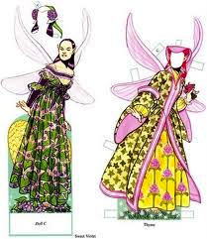

2) Character / Quotation Connections → Select a character from the book. Then select 4 quotations from the text that you feel reveals the character’s personality – not just things they said, or were said to them, but ANY part of the novel that you felt reveals some aspect of their personality, or connects most specifically to that character. You must explain what each quotation/sentence tells you about the character. You must also tell which page the quotation/sentence came from. (Hint: consider including your 1 quotation as part your explanation!)

3) Story Bag → Put together a bag that contains at least 5 items that would be useful to or significant to a character OR event in your novel. Include a description of each item and its relevance to the story as a whole. You can use a brown paper lunch bag, and items from around your house, or pictures of items you printed or cut out. (Hint: consider including your 1 quotation as part your description!)

