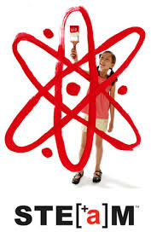

Bring the whole family ……

Thursday- March 13, 2014

6:00- 8:00 p.m. at Cloonan Middle School

**Families will participate in hands-on STEAM activities and leave with practical strategies and resources to strengthen our home-school partnership in the area of Mathematics, Science, and Literacy. “STEAM” is an acronym that stands for Science, Technology, Engineering, Arts, and Mathematics. Through “STEAM” students gain a well-rounded education that spurs a creative and explorative mind, for all. After a short keynote presentation, families will head to small group sessions with STEAM activities. In smaller sessions guest facilitators will guide parents and students through various activities with time to practice the new strategies. Visit the sessions of your choice.**

**\*\*\*Cloonan is proud to be a partner with the Connecticut Science Center through the School and Community Partnership. The Science Center will run 2 hands-on activities geared to getting parents and students excited about science in a fun and interactive way**

There will be prizes, raffles, and refreshments. Come one, Come all!

If you have any questions please email Mrs. Mody at [*lmody@stamfordct.gov*](mailto:lmody@stamfordct.gov)

Please return one copy per family to school by Monday, March 10, 2014.

**Keep the top portion for yourself and cut off the bottom section to return to school.**

---------------------------------------------------------------------------------------------------------------------------------

Our Family: The __________________ Family will be attending

Number of adults: __________

Number of children: ____________

Homeroom teacher: ________________