CPEP –
Connecticut Pre-Engineering Program
Catalysts Powering Educational Performance
Have fun and solve design challenges.
Engineer and build motor boats, race cars, roller coasters and mag-lev trains. Choose your best projects to show and compete at a state-wide meeting in May.
You must commit to meeting one to two days each week to help your team design the projects. Students from all grades are eligible. Win prizes and recognition at the CPEP day in May 2013.
Days: Tuesdays, Thursdays, October 4th, 2012 to May 4th, 2013
Time: 2:30 – 3:45
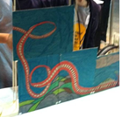
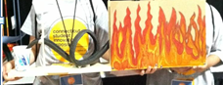
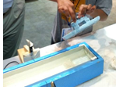
Register: 21st Century CPEP application (see Mr. Petrescu) cpep.org for information on the state program
Roller Coasters
Motor Boats

