**CLOONAN MIDDLE SCHOOL ANNOUNCES ITS NEW FUNDRAISER MARCH 25th – APRIL 5th!**



**IMPORTANT DETAILS**

Payment due date: **April 5th**

Checks payable to: **Cloonan PTO**

Turn-in: **Please return all forms to homeroom teacher by**

**April 5th**

**Make sure to make a copy (or take a picture) of your order form!**

Sales Tax Info: DO NOT COLLECT SALES TAX

You will be notified when orders are ready for pick-up!

## Our latest fundraiser will help us with *6th, 7th and 8th Grade Events*. This time around, we have partnered with Mixed Bag Designs and we are selling great products that have something fun for everyone in the family. These colorful bags and accessories are reusable, recyclable and ridiculously cool.

For every purchase, we get **50**% back and it all goes to a great cause! This is guilt free, eco-friendly shopping at its best - and we need all the help we can get!

## 

If you have any questions please contact **Christine Weinreb –(203)912-6710 or cweinreb125@gmail.com**

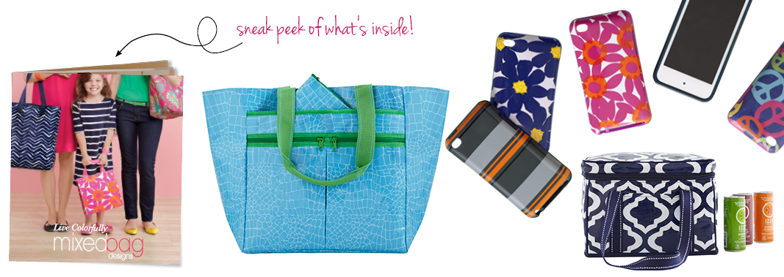

It’s easy for out-of-town friends & family to support us as well by shopping online!

* Go to **www.mixedbagdesigns.com** – click on **ONLINE STORE**.
* After checkout, add our **ID#:186537** plus the referring participant’s name
* We get 40% back on all of those online purchases!